CUD STUDENT CLUBS AND SOCIETIES
Type | Club / Society | President
Social Club | CUD Cares | Hanan Akram
 | Student Volunteers | Annette Thomas
 | Wellness | Sania Rahman
 | CMUN | Neil Jhaveri
 | Dance | Riddhi Kapadia
 | Music | Dwayne Menezes
 | Art | Reem Alzeyoudi
 | Drama | Mohammed Alinejad
 | Philosophy | Satvika Appikonda
 | Photography | Bianca Sengco
 | Women in STEM | Sukhroop Kaur
 | Fashion Club- Couture & Culture | Riddhi Kissinger
Academic Society | Psychology | Aaliyah Nizam
 | Eco-Lution | Lillian Husam
 | IEEE | Danica Chloe Reyes
 | Communication | Habiba Kapadia
 | Business | Riddhi Kapadia
 | AI | Nathan Kahsay Kidanu
 | Finance | Ishaan Rai
 | Case Study Lab | Khrystyna Kramchanina
 | CoLab | Nazla Chy
 | EcoRise innovation hub | Anas Altaweel

ECO-LUTION CLUB
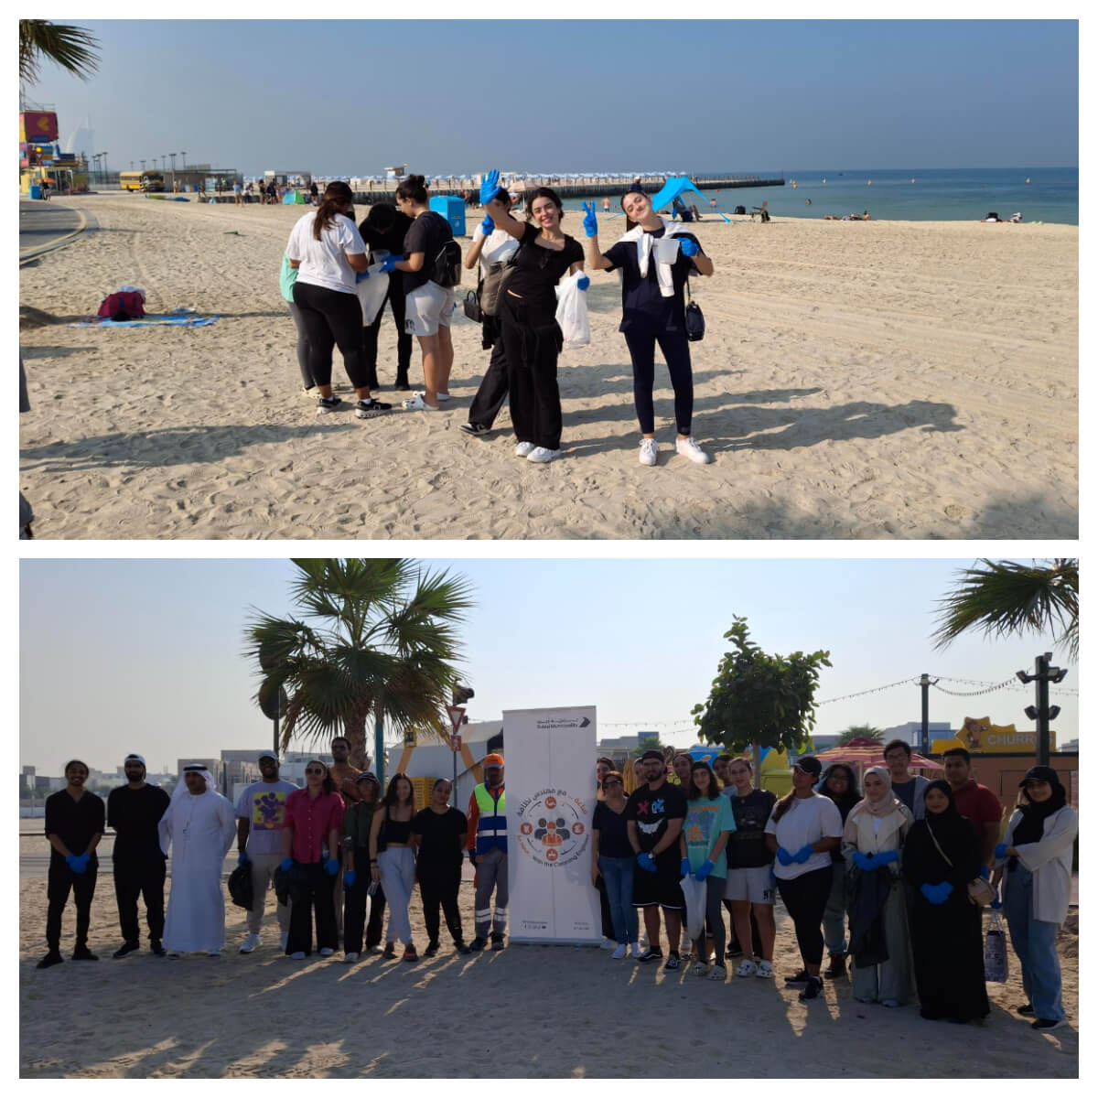
The Eco-lution Club is Canadian University Dubai's active student body for environmental stewardship and sustainable action. Our mission is to foster a culture of responsibility through education and hands-on engagement. Members participate in a diverse range of activities, including community cleanups to protect local marine biodiversity and immersive learning experiences to understand vital conservation efforts. Eco-lution provides a platform for students to connect with like-minded peers, apply their knowledge to real-world challenges, and become leaders in the movement for a sustainable future. 

Eco-Lution Club Activities
Depicted above, in November 2024, the CUD Eco-lution Club participated in the "AnHourwithCleaner" initiative, in coordination with Dubai Municipality. The activity aimed to raise awareness about the importance of maintaining clean beaches to protect marine biodiversity and promote a healthier environment.

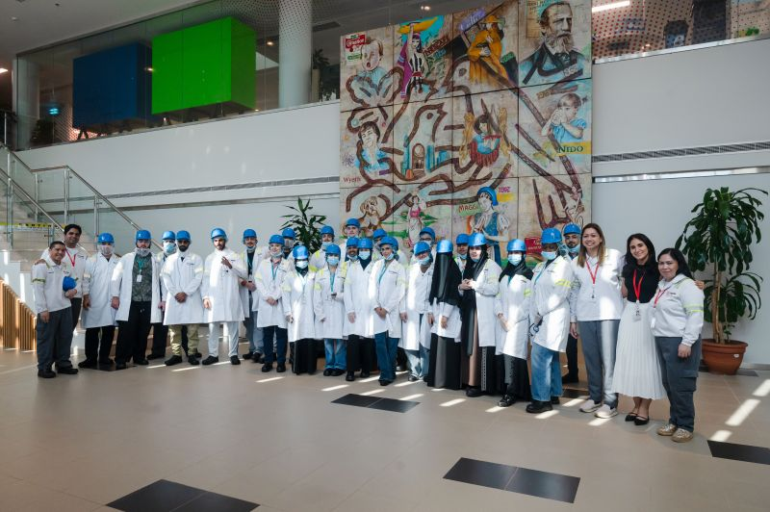 | In October 2024, Public Health students at Canadian University Dubai embarked on an exciting field trip to the Nestle Factory. They gained invaluable insights into health, safety, and food safety practices within a leading global company. This hands-on experience was instrumental in bridging the gap between classroom learning and real-world applications.
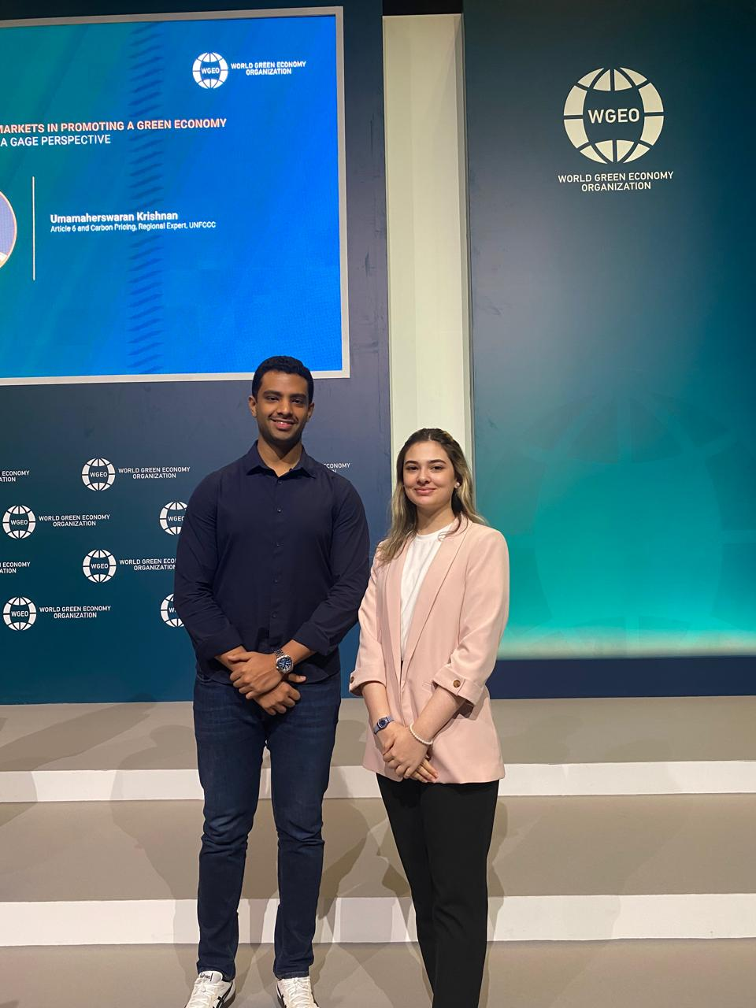 | Environmental Health Management students Mahshid Sadeghi and AbdulAziz AlKhalaf represented Canadian University Dubai in a focus group session hosted by the Global Compact Network UAE and the UN Resident Coordinator Office (RCO) at the World Green Economy Summit (WGES) 2024. The session aimed to gather valuable insights from UAE youth as they worked to bridge the gap between education and employment, particularly in the sustainability sector.
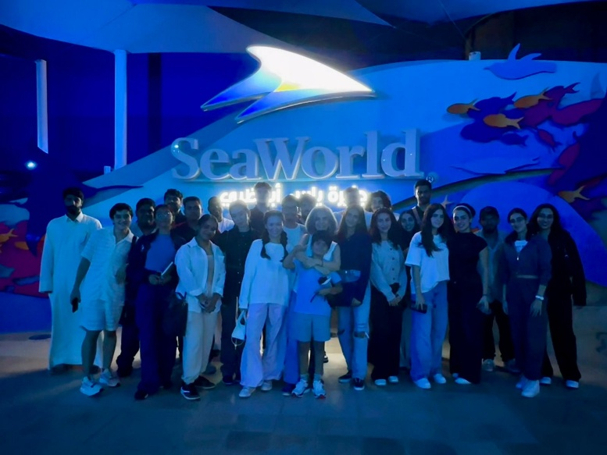 | Public Health students visited the Yas SeaWorld Research & Rescue Center in Abu Dhabi, where they explored the Center's vital role in marine conservation. As the region's largest facility of its kind, the Center focuses on rescuing and rehabilitating injured marine animals with a commitment to returning them to their natural habitats. Students learned about innovative initiatives and extensive research on the Arabian Gulf's unique ecosystems, aimed at developing methodologies for their restoration and conservation. Through hands-on experiences and educational programs, students gained a deeper understanding of marine life and the importance of protecting these fragile environments. This visit reinforced the Center's mission to inspire future generations to champion marine conservation efforts.
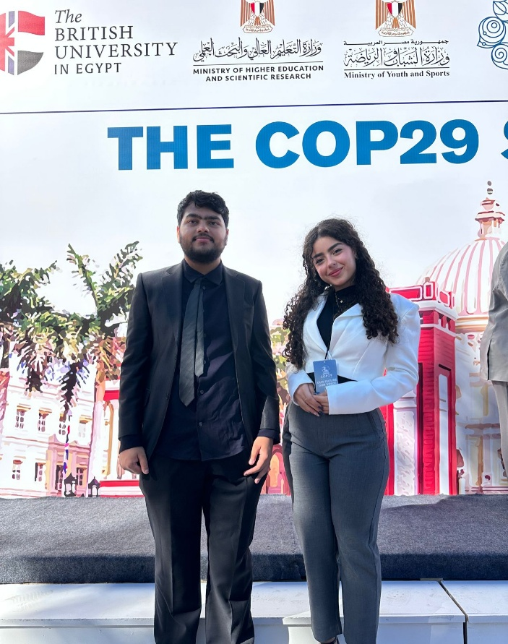 | As part of ongoing efforts to enhance the visibility of the Environmental Health Management Program and its commitment to the UN Sustainable Development Goals (SDGs), climate change initiatives, and environmental protection, Lillian Husam and Saad Naz from the Environmental Health Management Program were selected to attend the CoP29 Mock Conference held in Egypt in October 2024. At the conference, students simulated roles as country delegates, chief negotiators, and non-state actors, discussing and voting on research-based resolutions.
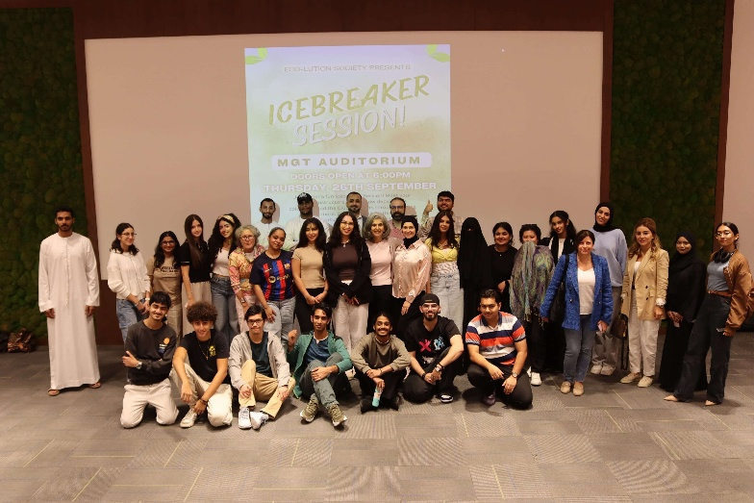 | The Eco-lution Club recently hosted its icebreaker event for the 2024-2025 academic year, welcoming new students from the Public Health Department. This engaging event aimed to foster connections among students while promoting sustainable practices and environmental awareness. It served as an introduction to the Eco-lution Club and the Public Health program, encouraging students to engage with their peers and learn about sustainability initiatives. Activities included interactive games and discussions on environmental topics, emphasizing the importance of sustainability in public health. Participants enjoyed a mix of fun and educational experiences designed to enhance their understanding of eco-friendly practices.
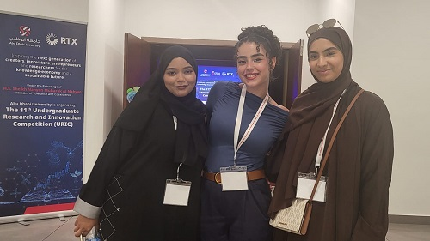 | Public Health students participated in the Eleventh Undergraduate Research and Innovation Competition held by Abu Dhabi University on May 23, 2024, under the category of Health Sciences. The research was about Evaluating Awareness and Performance towards COVID-related Disinfectant Use: A Comparative Study between Jordan and United Arab Emirates.
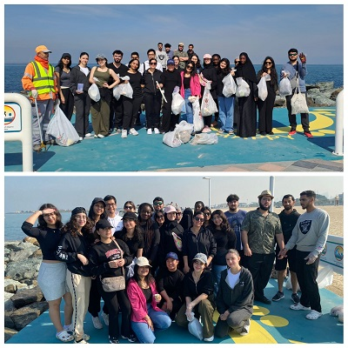 | Public Health students participated in a beach clean-up, aiming to raise awareness about the importance of maintaining clean beaches to protect marine biodiversity and promote a healthier environment.
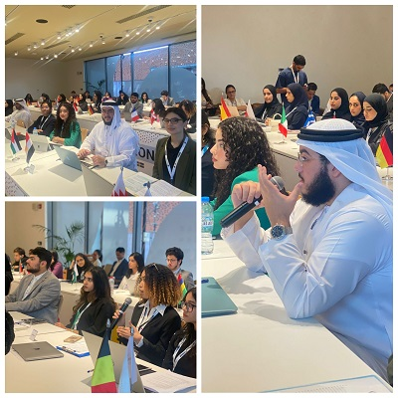 | On October 14th, 2023, Canadian University Dubai was represented by students from various departments, including the Department of Public Health, and Student Council; at the Climate Ambassadors Programme (CAP), held at Expo City in Dubai. The program was organized by the UAE’s Ministry of Climate Change and Environment, in collaboration with the Expo School Program, in support of the UAE’s Year of Sustainability, and 28th Conference of the Parties (COP28) to the UN Framework Convention on Climate Change, held in Dubai. The program aimed to provide students across the nation with insights into the discussions and negotiations that take place between nations at COP28, with the vision to develop the environmental leaders of tomorrow and nurture climate change.

Get Involved
Get in touch with the Student Success Center (SSC) is to guide and support you through your personal and academic journey at CUD. The SSC is a place where you can receive personal and academic support, attend valuable workshops, work on your assignments, find resources, prepare for exams, get to know and be involved in extracurricular activities, mentoring, and more.
Email: StudentSuccess@cud.ac.ae.

